DNA Sequence Analyzer

Submitted by: Sanskriti kumari
Course: Introduction to problem solving and programming [CSE1021]
Date: 26 mar2026

INTRODUCTION
DNA (Deoxyribonucleic Acid) is the genetic material present in living organisms. It contains important biological information that is essential for growth, development, and functioning. Analysing DNA sequences is a fundamental part of bioinformatics.
This project focuses on building a simple tool using Python to perform basic DNA sequence analysis. It helps in understanding how programming can be applied in biological data processing.

Objective
The objective of this project is to develop a Python-based application that can analyse DNA sequences by validating input, counting nucleotides, calculating GC content, and generating reverse complement.
Methodology
The project follows a simple step-by-step approach:
1. The user inputs a DNA sequence.
2. The program validates whether the sequence contains valid nucleotides (A, T, G, C).
3. If valid, the program counts each nucleotide.
4. It calculates GC content using a formula.
5. It generates the reverse complement of the sequence.
6. The results are displayed to the user.
5. Tools and Technologies Used
Python programming language
- Basic concepts: functions, loops, conditional statements

Features of the Project

- DNA sequence validation
- Nucleotide counting (A, T, G, C)
- GC content calculation
- Reverse complement generation
- Simple and user-friendly execution
- Sample Input and Output

Input:
ATGCGTA

Output:
Valid DNA sequence
Nucleotide Count: A=2, T=2, G=2, C=1
GC Content: 42.86%
Reverse Complement: TACGCAT

Result
The project successfully analyses DNA sequences and provides accurate results for nucleotide count, GC content, and reverse complement. It demonstrates the application of Python in basic bioinformatics tasks.

Conclusion

This project helped in understanding how programming can be used in biological data analysis. It improved my knowledge of Python as well as basic bioinformatics concepts.

Future Scope (IMPORTANT)
- Development of a graphical user interface (GUI)
- Support for file-based DNA input
- Integration of advanced bioinformatics tools
- Expansion to protein sequence analysis

Output screenshot
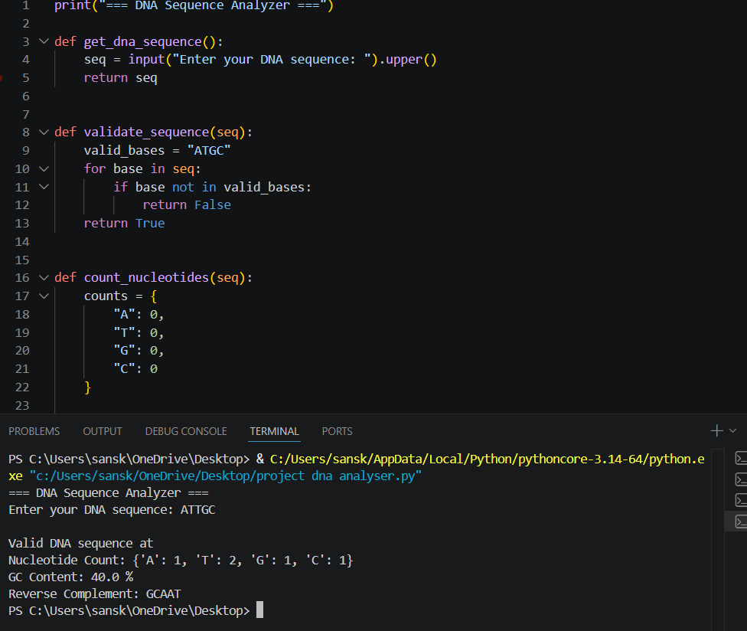
This screenshot shows the execution of the DNA sequence analyser program.

